
PB-T2/ECQP/1221/B 21-APR-2022
PREBOARD EXAMINATION 3 – TERM 2 (2021-2022)
Subject: ECONOMICS  Grade: XII |  | Max. Marks: 40  Time: 2 Hrs
Name: |  |  | Section: | Roll No:
General Instructions:
- This is a Subjective Question Paper
- This paper contains 5 questions of 2 marks each, 5 questions of 3 marks each and 3 questions of 5 marks each
- 2 marks questions are Short Answer Type Questions are to be answered in 30-50 words.
- 3 marks questions are Short Answer Type Questions are to be answered in 50-80 words.
- 5 marks questions are Long Answer Type Questions are to be answered in 80-120words.
- This question paper contains Case/Source Based Questions.
1. | “Final goods are those goods which are consumed only by the households”. Defend or refute the given statement with a valid argument.  OR  All machines are not capital goods. Justify this statement. |  |  |  | (2)
2. | Answer the following questions based on given figure.  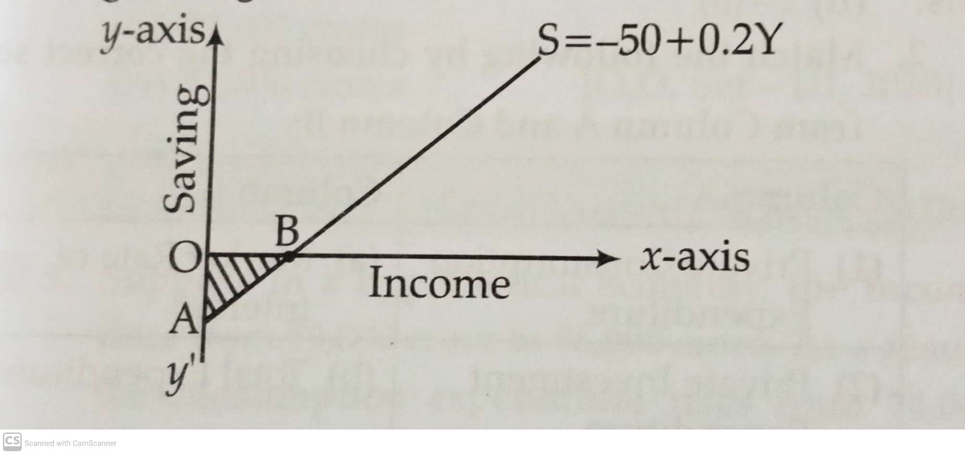  - What does the shaded area AOB indicate?  - What is the significance of point B? |  |  |  | (2)
3. | Giving reasons, state whether the following statements are true or false.  a) APS is always greater than zero.  b) Value of investment multiplier varies between zero and infinity.  OR  In an economy 75 percent of the increase in income is spent on consumption. Investment is increased by ₹ 1000 crores.  Calculate  - Total increase in income.  - Total increase in consumption expenditure. |  |  |  | (2)
4. | What makes casual labourers more vulnerable?  OR  “Infrastructure contributes to the economic development of a country”. Do you agree? Explain. |  |  |  | (2)
5. | ‘India has emerged as a hotspot for medical tourism’. Defend the statement with valid arguments. |  |  |  | (2)
6. | How will you treat the following while estimating domestic product of a country? Give reasons for your answer  - Profits earned by branches of country’s bank in other countries.  - Gifts given by an employer to his employees on Independence Day.  - Purchase of goods by foreign tourists. |  |  |  | (3)
7. | a) Define full employment in the economy.  b) Discuss the situation when aggregate demand is more than aggregate supply at full employment income. |  |  |  | (3)
8. | a) Define carrying capacity of environment.  b) “If the rate of resource extraction exceeds the rate of regeneration, it leads to reduction in carrying capacity of the environment”. Discuss the rationale of the given statement with valid reasons. |  |  |  | (3)
9. | Read the following text carefully and answer question number 9 and 10 given below:  China and India are the two emerging economies in the world. As of 2021, China and India are the 2nd and 5th largest economies in the world, respectively, on a nominal basis. On a PPP basis, China is at 1st, and India is at 3rd place. Both countries share 21% and 26% of the total global wealth in nominal and PPP terms, respectively. Among Asian countries, China and India together contribute more than half of Asia's GDP.  In 1987, the GDP (Nominal) of both countries was almost equal; even in PPP terms, China was slightly ahead of India in 1990. Now in 2021, China's GDP is 5.46 times higher than India. On a PPP basis, the GDP of China is 2.61x of India. China crossed the $1 trillion mark in 1998, while India crossed nine years later in 2007 on an exchange rate basis.  Both countries have been neck-to-neck in GDP per capita terms till 1990. As per both methods, India was richer than China in 1990. In 2021, China is almost 5.4 times richer than India on the nominal and 2.58 times richer in the PPP method. The per capita rank of China and India is 63rd and 147th, resp, in nominal. The per capita rank of China and India is 76th and 130th, resp, in PPP  China attains a maximum GDP growth rate of 19.30% in 1970 and a minimum of -27.27% in 1961. India reached an all-time high of 9.63% in 1988 and a record low of -5.24% in 1979. From 1961 to 2019, China grew by more than 10% in 22 years while India never. GDP growth rate was negative in five and four years for China and India, respectively.  According to CIA Fackbook, the sector-wise GDP composition of India in 2017 are as follows: Agriculture (15.4%), Industry (23%), and Services (61.5%). The Sector-wise GDP composition of China in 2017 are Agriculture (8.3%), Industry (39.5%), and Services (52.2%).  Source: -  World Bank: Nominal, PPP, Nominal per capita, PPP per capita  International Monetary Fund  Date:16th May 2021  Compare and analyze the given data of India and China with valid arguments.  Annual Growth of GDP (%), 1980-2017.  Source: Key indicators for Asia and Pacific 2016, ADB, Philippines; World Development Indicators 2018. |  |  |  | (3)
  Country | 1980-90 | 2015-2017.
  India | 5.7 | 7.3
  China | 10.3 | 6.8
10. | What are the similarities in the development strategies of India, Pakistan, and China? |  |  |  | (3)
11. | a) Given the following data, find the values of “Gross Domestic Capital formation” and “Operating Surplus”.  - Define externalities? Give an example of negative externality What is its impact on welfare?  OR  a) Money flows are opposite to real flows. How?  b) Calculate Sales from the following data. |  |  |  | (3)  (2)  (3)  (2)
  S.No | Particulars | Amount (in ₹ crores)
  i) | National Income | 22,100
  ii) | Wages and Salaries | 12,000
  iii) | Private Final Consumption Expenditure | 7,200
  iv) | Net Indirect Taxes | 7,00
  v) | Gross Domestic Capital Formation | ?
  vi) | Depreciation | 500
  vii) | Government Final Consumption Expenditure | 6,100
  viii) | Mixed income of Self employed | 4,800
  ix) | Operating Surplus | ?
  x) | Net Exports | 3,400
  xi) | Rent | 1,200
  xii) | Net Factor Income from Abroad | (-) 150
  SNo | Items | ₹ in lakh
  i) | Intermediate costs | 700
  ii) | Consumption of Fixed Capital | 80
  iii) | Change in stock | (-)50
  iv) | Subsidy | 60
  v) | Net Value Added at Factor Cost | 1,300
  vi) | Exports | 50
12. | Explain the determination of equilibrium level of national income using ‘saving and investment’ approach. Use diagram. Also explain the effects if planned savings is greater than planned investment. |  |  |  | (5)
13. | 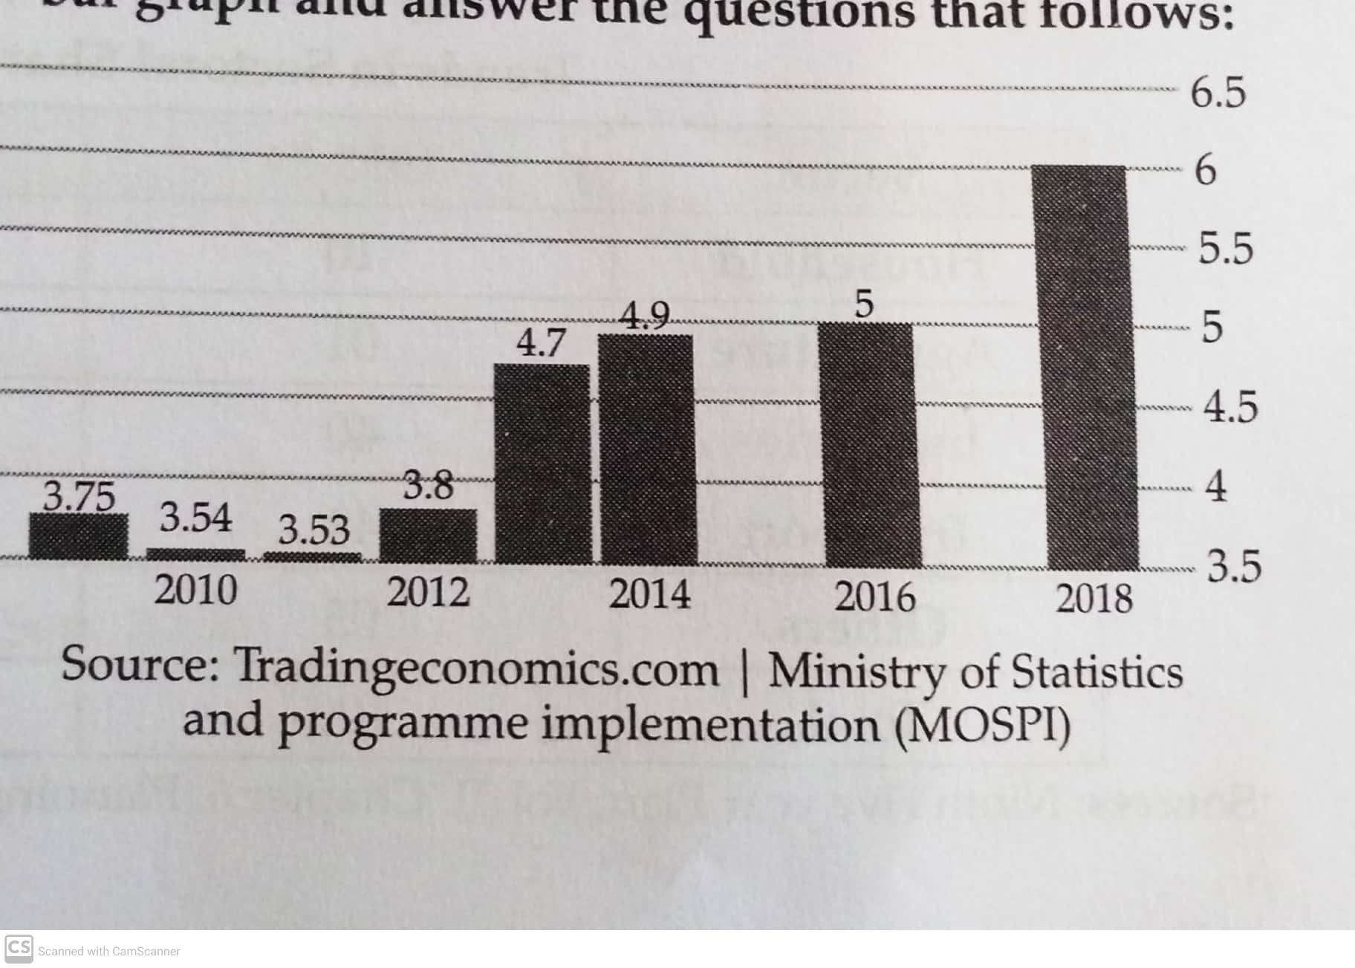  Read the trend of unemployment as shown in the bar graph and answer the questions that follows.  a) With reference to the graph:  i)What can you say about the state of unemployment in India?  ii) What type of unemployment is prevalent in India?  b) “There are some urgent environmental problems faced by India currently.” Justify the statement. |  |  |  | (3)  (2)

